

|  |  |  |  |  |  |  |  |  |
| --- | --- | --- | --- | --- | --- | --- | --- | --- |
|  | | | | | | | | |
|  | | First Milestone | | | | |  | |
|  |  | | | | | | |  |
|  | | | |  |  | | | |
|  | | | |  |  | | | |
|  | | | | Date: 30/10/2022—Course: App DevelopmentStudent: Eyal KotlikTeacher: Hila Goren |  | | | |
|  | | |  | | |  | | |



|  |  |  |  |  |  |  |  |  |
| --- | --- | --- | --- | --- | --- | --- | --- | --- |
|  |  | | |  |  | | |  |
|  | Overview | | | | | | |  |
|  |  | | |  |  | | |  |
|  |  | |  | | |  | |  |
|  |  |  | As of now, I have successfully processed and properly formatted the primary data required for the app and I am in the process of doing the same for the more advanced abilities and armament options.  The data was processed using the “pandas” and “re” python libraries, and is sufficient to create a rudimentary demonstration of the app. | | |  |  |  |
|  | | | | |
|  |  |  |  |
|  |  |



|  |  |  |  |  |  |  |  |  |
| --- | --- | --- | --- | --- | --- | --- | --- | --- |
|  | |  |  | | |  |  | |
|  | | Specifications | | | | |  | |
|  | |  |  | | |  |  | |
|  | Python file and the Data The python file takes raw data downloaded from the website <https://wahapedia.ru> which hosts the rules for Warhammer 40k – the game whose army building this app seeks to simplify. Then the raw data if transformed into a more useful formant for a computer.  The data itself is currently organized into several CSV files (“|” is the delimiter), these files are sorted and filtered so most of the unnecessary information is removed so it becomes somewhat possible to navigate them. I intended to further refine this dataset in the revision of this milestone by properly formatting the wargear options and finishing the formatting of the special abilities of units. | | | | | | |  |
|  | The Game and the 1/11/2022 Revision | | |  |  | | |  |
|  | Warhammer 40k is a tabletop miniature game where each player picks an army, and then the players command these armies in a turn-based battle. The basics of combat in this game are dice rolls modified by each models’ abilities and characteristics. For a better understanding I recommend reading [how to make attacks](https://wahapedia.ru/wh40k9ed/the-rules/core-rules/#Making-Attacks) in the core rules of the game. | | |  | My current plans for the next revision (due on 1/11/2022) are to complete the formatting of the abilities (bar incredibly niche ones), processes the wargear options data, and create a (console based) demo for selecting a unit. | | |  |

|  |  |  |  |  |  |  |
| --- | --- | --- | --- | --- | --- | --- |
|  | Data Diagram | | | | |  |
|  | |  |  |  |  | |
|  |  | | | | |  |

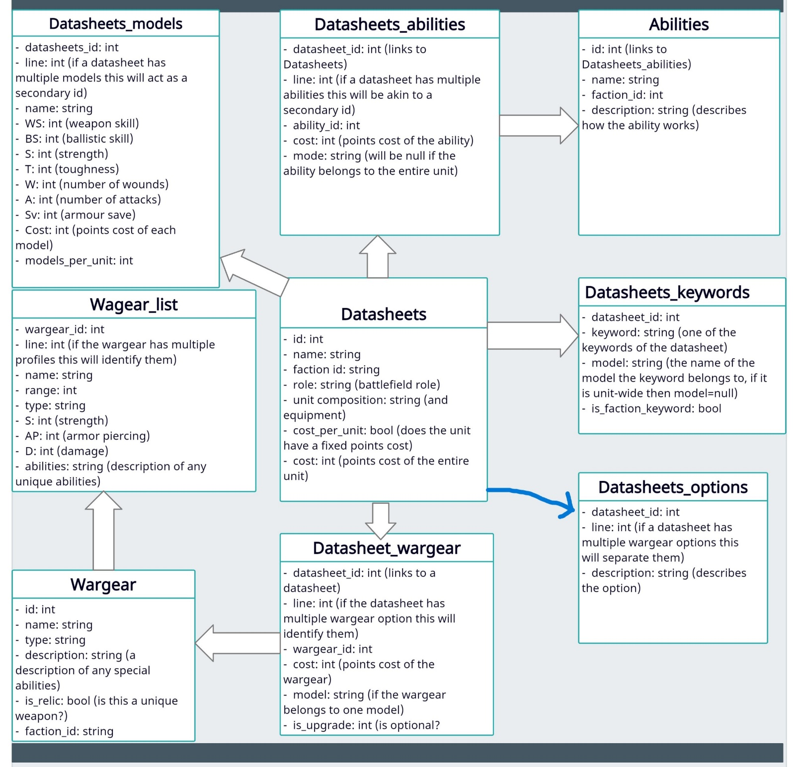

# Bibliography and Tools

* <https://www.w3schools.com>
* <https://docs.python.org/3/>
* <https://www.geeksforgeeks.org/>
* <https://stackoverflow.com/>
* <https://wahapedia.ru/>
* <https://app.creately.com/>
* <https://github.com/>